# PDIoT Data Collection Protocol

Welcome to PDIoT 2021! This year your task will be to develop a Human Activity Recognition model for classifying the following activities:

* Sitting (straight, bent forward, bent backward)
* Standing
* Lying down (left, right, on the back, on the front)
* Walking
* Running / Jogging
* Ascending and descending stairs
* Desk work
* General movement (sudden turns, bending down, getting up from chairs, anything else that doesn't qualify as an activity)
* Falling (on the knees, on the back, on the sides)

You will be using two types of sensors to collect data for these activities:

1. **The Respeck sensor** - worn on the lower left ribcage, attached with MeFix tape, sampling accelerometer and gyroscope data at 25Hz
2. **The Nordic Cube (Thingy)** - worn in the front right trouser pocket, sampling accelerometer, gyroscope and magnetometer data at 25Hz

You will then clean your data and add it to a shared repository. Everyone will be using data from this pool to train their models, regardless of which sensor they choose to use.

You will need an Android phone running Android 6.0 or above for this coursework. If neither you nor your team mate have an Android phone please let us know and we will provide you with one.

**The deadline for collecting and submitting this data is Week 3.**

The steps of this tutorial are the following:

1. Necessary equipment
2. Download the Thingy:52 app to set the frequency of the sensor at 25Hz
3. Download and install the PDIoT app
4. Connect to both sensors using the PDIoT app
   1. On phones which support NFC
   2. On phones which do not support NFC
5. Watch live data from both sensors
6. Sensor placement
7. Start recording data
8. Activity descriptions
9. Upload files to your computer
10. Verify your files and clean your data
11. Upload clean data to shared repository

## Necessary equipment

For this task you will need the following:

1. A smartphone running Android 6.0 or above. If neither person in your team has an Android phone we can provide you with one.
2. The Nordic Thingy:52 with a black rubber case
3. The Respeck sensor
4. A plastic bag for the Respeck sensor which prevents stickiness
5. MeFix tape for fixing the Respeck to the skin
6. Apps:
   1. Thingy:52 app
   2. PDIoT app
   3. Optional: Total Commander app
7. A GitHub account (make sure you have been given access to the necessary repositories)
8. Android Studio
9. An environment which can run Python3 and packages such as jupyter, pandas, numpy

## Downloading the Thingy:52 App

You will need to first download and install the Thingy:52 app to modify some settings. You can find the app here: <https://play.google.com/store/apps/details?id=no.nordicsemi.android.nrfthingy&hl=en_GB&gl=US>

Alternatively, you can download the code from GitHub and build the app on your phone: <https://github.com/NordicSemiconductor/Android-Nordic-Thingy>

## Setting the Thingy to sample at 25Hz

Connect your Thingy to the app by following the instructions. Then, navigate to “Configuration” in the sidebar menu. Switch to the “Advanced” tab and find the “Motion processing unit frequency” under “Motion settings”. Set this to 25Hz and click “Confirm” to apply the setting.

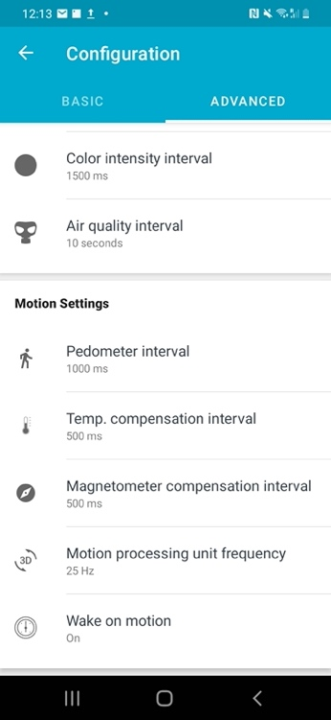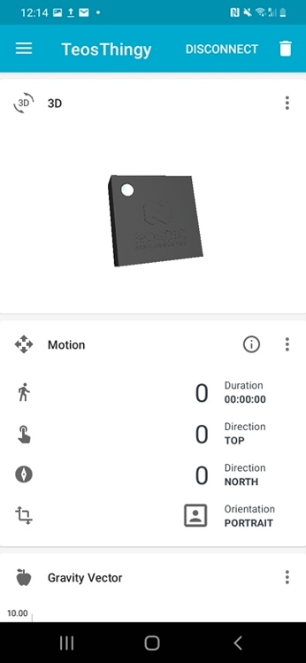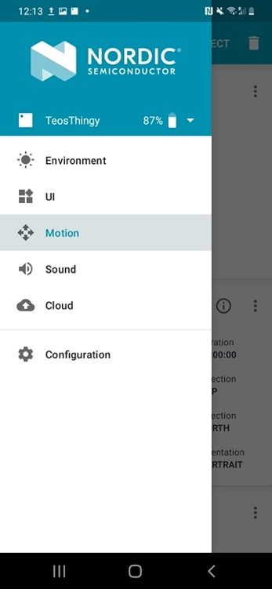

Finally, return to the Motion screen and click “Disconnect” in the top right corner to tear down the connection with the Thingy. You will now be able to connect to the Thingy from the PDIoT app.

## Downloading the PDIoT App

The application code can be found here:

<https://github.com/specknet/pdiotapp>

Download the repository on your local machine and open the project using Android Studio. Once the code loads, go to Build > Build Bundle(s) / APK(s) > Build APK. This will build a .apk file and save it in the project folder > app > build > outputs > apk > debug > app-debug.apk. You can then transfer this apk file to your phone and start the application.

Alternatively, if you have developer options enabled on your Android phone, you can build the app directly from Android Studio by selecting Run > Run app.

## Connecting to the Sensors

When you first install the application, you will need to connect it to the Respeck and the Thingy. Do so by navigating to the *Connect Sensors*activity. Here you will see two fields where you need to input the Respeck ID and the Thingy ID, respectively.

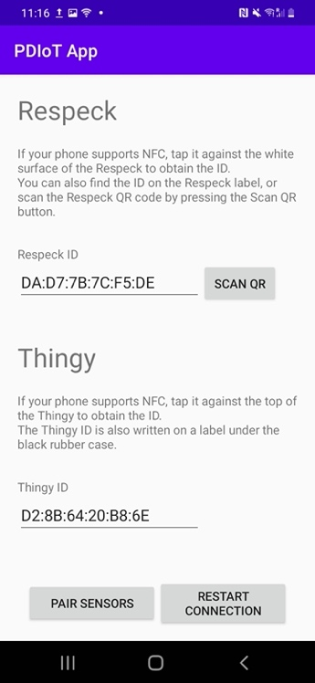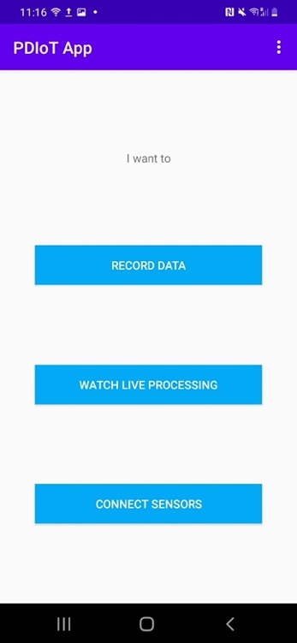

You have multiple choices for connecting the sensors:

* NFC pairing if your phone supports NFC
* Scanning the QR code of the Respeck
* Manually input the IDs into the fields

You should only need to pair these sensors once. Their IDs will be remembered by the app whenever you start it again.

Make sure the sensors are both on:

* Respeck – move the sensor around and it should blink **green** when it wakes up
* Thingy – turn on using the switch on the bottom left edge and it should blink **blue** when it is on.

## NFC pairing

If your phone supports NFC you can simply tap it against the white surface of the Respeck to get the Respeck ID autocompleted in the corresponding field.

Similarly, you can tap the phone on the front side of the Thingy (here shown without the rubber case) to get the Thingy ID autocompleted in the corresponding field.

## Scanning the Respeck QR code

If your phone does not support NFC, you can scan the QR code of the Respeck instead.

Every Respeck should have a QR code printed on its back. By pressing the *Scan QR* button, a camera view will pop up and you will be able to scan the Respeck QR code to pair it to your app. Only one Respeck can be paired with an app at one time.

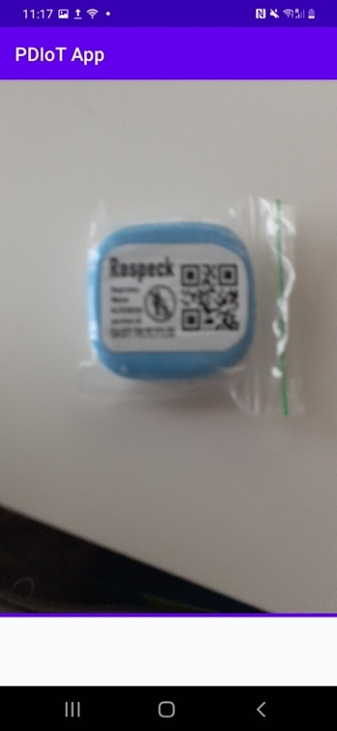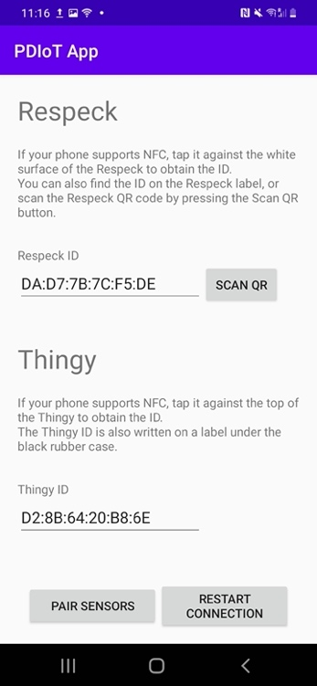

## Finding the Thingy ID

Unfortunately the Nordic Cubes do not have a QR code attached to them but you can find their ID (MAC address) on a label under the rubber case and NFC tag, as shown in the picture below.

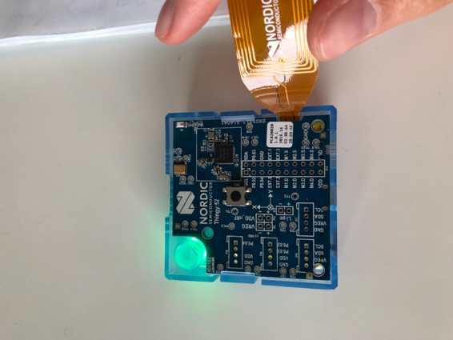

You need to manually input this code under the “Thingy ID” field.

## Establishing the connection

Once you have entered both sensors’ IDs you will be able to click the button “Pair sensors” to start the Bluetooth service and connect to the sensors.

If you ever need to change the sensors you can scan the IDs of the new sensors and click on “Pair sensors” again. This will restart the service with the new IDs.

If you have any connection issues, you can click on “Restart connection” to restart the Bluetooth service forcefully.

The sensors have differently coloured LEDs that change with connection states.

Thingy:

* **Blue** light -> sensor ON and NOT CONNECTED
* **Green** light -> sensor ON and CONNECTED
* No light -> sensor OFF

Respeck:

* **Green** light blink -> sensor ON and NOT CONNECTED
* **Blue** light -> sensor ON and CONNECTED
* **Red** light -> sensor ON and DISCONNECTED

So, when you connect to them, you have to watch out for the **Thingy to blink green** and the **Respeck to blink blue**.

## Viewing live data

You can view incoming data from both sensors in the “Watch live processing” activity. This will show you two live graphs of the accelerometer data from the Respeck (top) and Thingy (bottom). Both sensors should run at 25Hz.

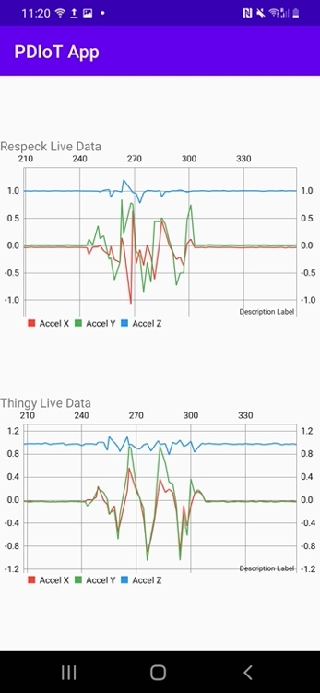

## Sensor placement

Everyone will need to wear the sensors in the same places to ensure consistency across the data.

The **Respeck** sensor should be placed on the **left lower ribcage**, with the blue half against the skin. Make sure that the Respeck is first put into the small plastic bag provided. You should be able to read the Respeck label when placing it on your chest – this ensures the sensor is held the right way up, as shown in the figure below.

Secure the sensor to the chest using the MeFix tape provided. If you run out of tape you should let us know and we will provide you with more.

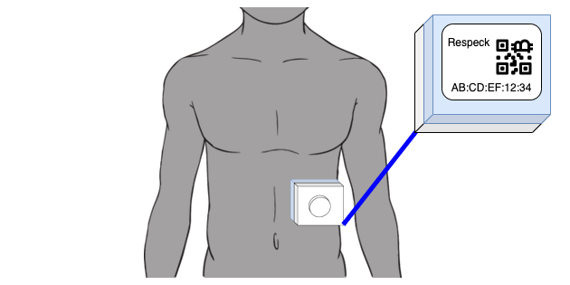

## The Thingy sensor should be placed in the front right pocket of your trousers, with the circle placed in the upper right corner and the USB port facing downwards.

## Recording data

Finally, you can record data in the *Record Data* activity. Choose the appropriate Sensor type and Activity and please use the university student number as the subject ID. You can enter any additional notes you have about the upcoming recording.

You will be able to verify that your sensors are running as expected by watching the Live Data fields at the bottom of the screen.

Hit *Start Recording* when you are all set up. **Please record each activity for 30 seconds**. When you are done with a recording, hit *Stop Recording*. If something goes wrong during the recording you can cancel it by pressing the *Cancel Recording* button.

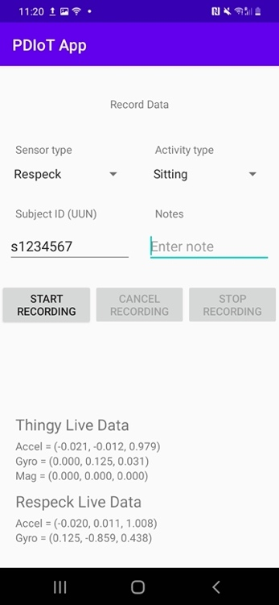

You are required to ensure the recording only contains one activity. For example, if you start recording data for walking and you only start moving after the first 3 seconds, you should trim the first 3 seconds of this recording, as they are not representative of the walking activity. The total length of your recordings AFTER TRIMMING should be 30 seconds.

If you accidentally collect less data for one activity please redo the recording.

Each student should take part in the data collection for both sensors. The only exception should be students who are distance learners for PDIoT and are not physically present at the university at the time of data collection, as we will not be providing them with hardware.

If you have any conditions that would prevent you from collecting any of the activities above (for example falling, if you have any injuries) please let us know in advance.

## Activity descriptions

Please follow these activity descriptions as closely as possible to ensure consistency across all collected data. The Lab Demonstrator will also make sure that you are performing the activities correctly.

* Sitting (straight, bent forward, bent backward)
* Standing
* Lying down (left, right, on the back, on the front)
* Walking
* Running / Jogging
* Ascending and descending stairs
* Desk work
* General movement (sudden turns, bending down, getting up from chairs, anything else that doesn't qualify as an activity)
* Falling (on the knees, on the back, on the sides)

1. **Sitting straight**

Sit down on a chair with your back straight. Breathe normally for 30 seconds. Try to not move, talk, cough or laugh during this recording.

1. **Sitting bent forward**

Sit down on a chair and lean forward. Breathe normally for 30 seconds. Try to not move, talk, cough or laugh during this recording.

1. **Sitting bent backward**

Sit down on a chair and lean backward in a relaxed position. Breathe normally for 30 seconds. Try to not move, talk, cough or laugh during this recording.

1. **Standing**

Stand up with your back straight. Breathe normally for 30 seconds. Try to not move, talk, cough or laugh during this recording.

1. **Lying down on the left side**

Lie down on an even surface such as a bed or a sofa. Make sure your torso is completely horizontal. Turn onto your left side. Breathe normally for 30 seconds. Try to not move, talk, cough or laugh during this recording.

1. **Lying down on the right side**

Lie down on an even surface such as a bed or a sofa. Make sure your torso is completely horizontal. Turn onto your right side. Breathe normally for 30 seconds. Try to not move, talk, cough or laugh during this recording.

1. **Lying down on the front**

Lie down on an even surface such as a bed or a sofa. Make sure your torso is completely horizontal. Turn onto your belly. Breathe normally for 30 seconds. Try to not move, talk, cough or laugh during this recording.

1. **Lying down on the back**

Lie down on an even surface such as a bed or a sofa. Make sure your torso is completely horizontal. Turn onto your back. Breathe normally for 30 seconds. Try to not move, talk, cough or laugh during this recording.

1. **Walking**

Find a space where you can walk in a straight line for 30 seconds or take as few sudden turns as possible. Walk at a normal pace and try to not stop during the recording.

1. **Running or Jogging**

Find a space where you can run or jog in a straight line for 30 seconds or take as few sudden turns as possible. Try to not stop during the recording.

1. **Ascending stairs**

Find a space where you can continuously climb a flight of stairs for 30 seconds, for example Appleton Tower. Walk up the stairs at a normal pace and do not stop for the 30 seconds of the recording.

1. **Descending stairs**

Find a space where you can continuously descend a flight of stairs for 30 seconds, for example Appleton Tower. Walk down the stairs at a normal pace and do not stop for the 30 seconds of the recording.

1. **Desk work**

Sit down on a desk chair in a relaxed position and type something on your computer, move the mouse around or write something on a piece of paper for 30 seconds. Try to not talk, cough or laugh during this recording or make any sudden movements.

1. **General movement**

Make dynamic movements for 30 seconds. This includes sitting down on a chair, getting up from a chair, bending down, suddenly turning around etc. The most important point is to continue moving for the full 30 seconds.

1. **Falling on the knees**

From a straight standing position, fall on your knees and stop on your hands. Do this for as many times as it takes to gather 30 seconds of falling data. You can use a pile of pillows to soften your fall.

1. **Falling on the back**

From a straight standing position, fall on your back on a soft surface, preferably a bed or a mattress. Do this for as many times as it takes to gather 30 seconds of falling data.

1. **Falling on the left**

From a straight standing position, fall on your left side on a soft surface, preferably a bed or a mattress. Do this for as many times as it takes to gather 30 seconds of falling data.

1. **Falling on the right**

From a straight standing position, fall on your right side on a soft surface, preferably a bed or a mattress. Do this for as many times as it takes to gather 30 seconds of falling data.

## Obtaining the recorded files

Files are saved on the phone’s internal memory as csv files, in the Android > app > data > com.specknet.pdiotapp > files > Filename.csv.

You can access these files either by:

* connecting your phone to a computer via USB and checking the internal memory, or
* navigating to this folder from a file browser app on your phone and send them via Bluetooth, email, message etc.

Depending on which Android version you are running, you might need additional apps rather than the pre-installed ones to get to these files. From Android version 11, you should use apps like Total Commander to view hidden system files. Any Android version lower than 11 will allow you to see these files in a normal file browser on your phone.

The filename is formatted as follows: {sensorType}_{studentID}_{activityType}_{timestamp}.csv. This should ensure that each file has a unique name among all students.

If you are using a Redmi phone provided by us and you need to obtain the files via USB you might need to restart the phone to see the new files appear in the file browser on your computer.

## Verifying the files and cleaning the data

Use your preferred data analysis tool to process your files. You can follow the tutorial X (TODO!!!!) for instructions on how to quickly plot signals using Python.

Please check your recordings for the following:

* Activities should start at second 0 and finish at second 30.
* If there is a period of pause before the activity is performed, or if the recording was stopped too late, please trim the recording.
* The total length of the recording AFTER TRIMMING should be 30 seconds.
* There should be only one activity performed per recording, and that activity should match the recording title
* The frequency of both files should be around 25Hz.
* There are no obvious outliers in the data, such as sudden signal jumps.
* The column headers are consistent across recordings
  + Respeck column headers: timestamp, accel_x, accel_y, accel_z, gyro_x, gyro_y, gyro_z
  + Thingy column headers: timestamp, accel_x, accel_y, accel_z, gyro_x, gyro_y, gyro_z, mag_x, mag_y, mag_z

(TODO – might add sensor_type, activity_type, subject_id, rec_id to these)

## Uploading clean data to a shared repository

Upload your own data to the shared repository: <https://github.com/specknet/pdiot-data>.

You should gather all your files under a folder named with your student ID (e.g. s1234567, all lowercase, no spaces). Upload this folder to the GitHub repository.